Syllabus points:

* Characteristics and needs of specific populations.
* Access and equity issues of specific populations.
* Quantitative and qualitative measures for detecting health inequities and/or injustices.
* Epidemiological data.
* Social determinants of health.
* Purpose and characteristics of the 5 levels of need within Maslow’s Hierarchy of Needs.
* Socioecological model of health and its role in understanding and addressing public health problems.
* Individual.
* Interpersonal.
* Organisational.
* Community.
* Society.

Socioecological Model

Health: A state of complete physical, mental and social wellbeing free from disease and illness.

Purpose: To understand how factors influence human behaviour [1 mark].

Purpose: It’s a conceptual model that outlines how health status of an individual is influenced by their attitudes, behaviours, relationships, community and society. Each level of the model interrelates with each other and the model aims to understand how factors influence human behaviour to improve the health of all individuals [2 marks].

**– What Does It Look Like?**

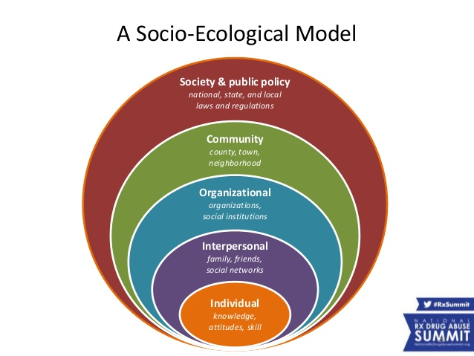

**– Why Does It Exist?**

* Human behaviour is influenced by a variety of factors.
* Understanding how these factors interrelate is important in understanding how they influence behaviour.
* It can be used to help explain why certain behaviours are more prevalent in certain populations.
* Know why certain behaviours are more prevalent → implement public health approach → prevent harm and illness → improve health.

**– What Information Does It Provide Us With?**

* The 5 levels cover a variety of factors that can influence human behaviour.
* We can also see how the factors within each level interact with each other to contribute to certain behaviours.
* It can help explain health behaviour and be used to guide health promotion to address unhealthy behaviour.

**– How Can We Use It?**

Health promoters can apply the model to help gain understanding of the factors that influence human behaviour and how these factors interrelate.

Levels:

1. Individual.
2. Interpersonal.
3. Organisational *.
4. Community *.
5. Societal.

(Idiotic Imagination Overpowers Communal Spaghetti)

Individual:

* Characteristics of the individual, including knowledge, attitudes, behaviour, self-concept, skills and decision making. Includes:
* Biological factors (genetics).
* Demographics (age and gender, racial ethnicity) *.
* Personality and emotional intelligence *.
* Intentions, will and self-control.
* Literacy and health literacy levels *.
* Sexual orientation.
* Beliefs, values and attitudes.
* Financial resources.

Interpersonal:

* Explores how close relationships impact health behaviours. Includes:
* Considering which relationships influence the most and how we’re influenced by different types of relationships (parents vs peers).
* An individual’s communication skills (leadership, tolerance, respect for others).

Organisational:

* Examines the way that a person lives, works and learns within the rules, policies and expectations of institutions (schools, churches, workplaces, community organisations, healthcare services).

Community:

* Community contexts in which organisations may interact and the community norms that cross all organisations within the community. Includes:
* Businesses.
* Transportation.
* The built environment e.g., parks and buildings.
* Community villages.

Societal:

* Examines factors e.g.,:
* Cultural norms and collective attitudes.
* Economic and social policies (legislation at a local, state and national level).
* Restrictive policies e.g., high taxes.
* A lack of policies e.g., requirements for childhood immunisations.
* Political structures (democracy or other voting systems).

The levels invariably overlap and interact with each other.

Interpersonal interactions happen in the organisational level.

Individuals bring cultural and community norms with them into interpersonal and organisational settings.

Maslow’s Hierarchy of Needs

4 types of needs must be satisfied before a person can achieve self-actualisation.

Climbing the hierarchy is achieved by satisfying one set of needs at a time.

Humans are driven to satisfy the lower needs and are drawn to meet the higher ones.

Lacking the deficiency needs creates tension within the individual.

5 levels:

1. Physiological needs.
2. Safety needs.
3. Social needs.
4. Esteem needs.
5. Self-actualisation.

(Peter Saved Samoan Elephants)

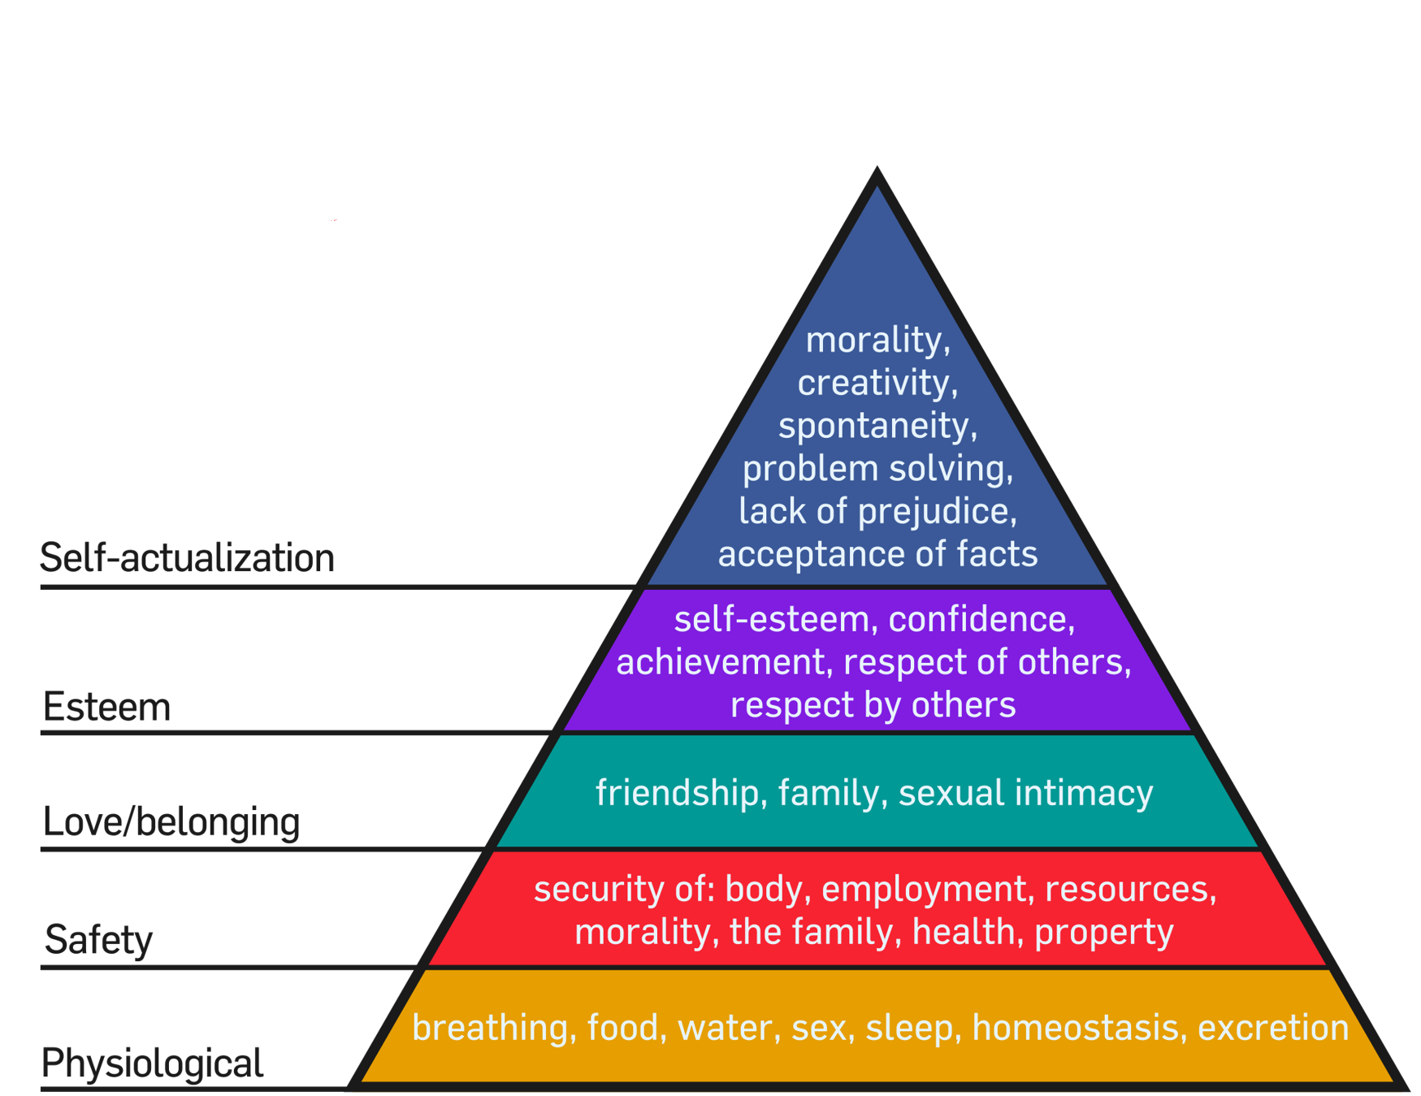

|  |  |
| --- | --- |
| Physiological needs | Air, food, water and sleep are essential. If these basic needs aren’t met, then an individual won’t consider the higher needs. |
| Safety needs | Safety and security to be free from the threat of physical and emotional harm. Includes living in a safe area, medical insurance, job security and financial reserves. If an individual doesn’t feel safe and secure, they won’t consider higher needs. |
| Social needs | We fulfil our desires to be social through interactions with others. This includes friendship, belonging to a group, giving and receiving love and intimate relationships. Until we feel like we belong, we won’t consider the need to feel important. |
| Esteem needs | When we feel accepted and loved by those around us, we seek out the feeling of importance and recognition. Divided into 2 types of motivators. External – drivers out of your control e.g., attention, social status and recognition. Internal – Drivers in your control e.g., accomplishment and self-respect. |

Self-actualisation is never fully satisfied because as individuals grow psychologically, so do the opportunities presented to them.

Self-actualised people tend to have motivators e.g., truth, justice, wisdom and meaning.

Characteristics of self-actualised people:

* Peak experiences.
* Realistic.
* Autonomous.
* Self-acceptance.
* Problem-centred.
* Spontaneous.

(PRASS P)

|  |  |
| --- | --- |
| Peak experiences | Frequent peak experiences. |
| Realistic | The self-actualised individual is able to view life as it unfolds both logically and rationally. |
| Autonomous | Self-actualised people tend to be very independent. They don’t conform to other people’s ideas of happiness or contentment. This allows the individual to live in the moment and appreciate the beauty of each experience. |
| Self-acceptance | Self-actualised people accept themselves and others as they are. They tend to lack inhibition and are able to enjoy themselves and their lives free of guilt. They treat others the same regardless of background, current status or other socioeconomic and cultural factors. |
| Spontaneous | Self-actualised people tend to be open, unconventional and spontaneous. While these people can follow generally accepted social expectations, they don’t feel confined by these norms in their thoughts or behaviours. |
| Problem-centred | Self-actualised individuals are often motivated by a strong sense of personal ethics and responsibility. They enjoy applying their problem-solving skills to real-world situations and they like helping other people to improve their own lives. |

Characteristics & Needs of Specific Populations

Specific population: A subgroup of the main population of a country or state. It consists of a group of people with similar characteristics and/or needs.

Examples:

* Aboriginal and Torres Strait Islanders (Indigenous).
* Individuals living in rural/remote areas.
* The elderly.
* Socioeconomically disadvantaged people.

Characteristics: Features or qualities that typically belong to that group.

Characteristics “define” and “identify” groups from the general population.

Needs: What the group requires to achieve good/better health.

Consider what their deficits/problems are and what they need to overcome these.

Access: The right to obtain something or make use of something. The ability to reach or gain entry to a place or service.

Equity: All people have an equal opportunity to develop and maintain health through fair and just access to resources for health.

Health inequities: Avoidable inequalities in health between groups of people within countries and between countries. These inequities are unfair or unjust.

Health inequalities: Differences in health status or in the distribution of health determinants between different population groups.

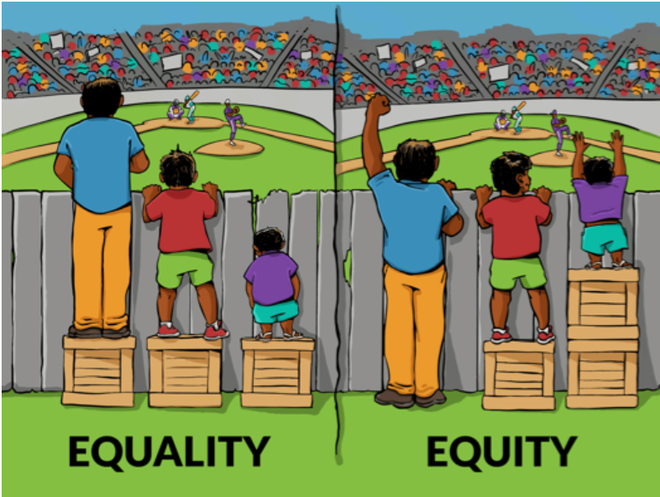

Equality is equal distribution regardless of differences in needs whereas equity is distribution according to needs.

Access and equity opens the door for increased opportunities for specific populations to achieve the same level of health as the main population. There are often barriers that make it difficult for people in these specific populations to access health services.

|  |  |
| --- | --- |
| Equality: | Equity: |
| A city cuts the budget for 25 community centres by reducing the operational hours for all centres by the same amount and at the same time. | The city determines which times and how many hours communities actually need to reduce their community centres and reduces hours for centres that aren’t used as frequently. |
| A community meeting, where all members of the community are invited, about a local environmental health concern is held in English although English isn’t the primary language for 25% of the residents. | The community leaders hire translators to attend the meeting or offer an additional meeting held in another language. |

* Health promotion needs to address the issues of access and inequity.
* Health promotion gives priority to specific populations who are “at risk”.
* Health promotion focuses health initiatives to target the social determinants of health.
* Health promotion aims to reduce inequity.

5 A’s of access:

1. Accessibility.
2. Affordability.
3. Availability.
4. Acceptability.
5. Adaptability.

(Can Vegan Ducks Fly and Clap?)

Q: How do qualitative and quantitative measures work together to determine the presence of inequity?

The quantitative data gives information about how much disease there is and who has the disease, and qualitative data helps explain why or how.

Q: How can they explain why this inequity occurs?

The qualitative data can give information on why the disease is present and what might be causing the health problems.

|  |  |
| --- | --- |
| Term: | Definition: |
| Health | A state of complete physical, mental and social wellbeing free from disease and illness. |
| Specific population | A subgroup of the main population of a country or state. It consists of a group of people with similar characteristics and/or needs. |
| Characteristics | Features or qualities that typically belong to that group. |
| Needs | What the group requires to achieve good/better health. |
| Access | The right to obtain something or make use of something. The ability to reach or gain entry to a place or service. |
| Equity | All people have an equal opportunity to develop and maintain health through fair and just access to resources for health. |
| Health inequities | Avoidable inequities in health between groups of people within countries and between countries. These inequities are unfair or unjust. |
| Health inequalities | Differences in health status or in the distribution of health determinants between different population groups. |